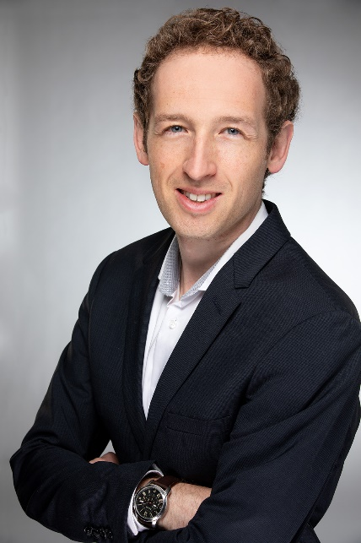

Basil Preisig, Dr.

Department of Comparative Language Sciences, University of Zurich

[basil.preisig@uzh.ch](mailto:basilchristoph.preisig@uzh.ch)

Link to my UZH Webpage

<https://www.comparativelinguistics.uzh.ch/en/staff/preisig.html>

I obtained my PhD in Neuroscience at the University of Bern in 2016. Afterwards, I did a postdoctoral fellowship at the Donders Institute for Cognitive Neuroimaging and the Max Planck Institute for Psycholinguistics in Nijmegen before I joined the Neurolinguistcs lab at the University of Zurich in 2019. In autumn 2021, I was awarded the prestigious Ambizione career grant by the Swiss National Science Foundation to start my own research group at the Department of Comparative Language Science.